**KWAME NKRUMAH UNIVERSITY OF SCIENCE AND TECHNOLOGY**  
**COLLEGE OF ART AND THE BUILT ENVIRONMENT**  
**FACULTY OF ART**  
**DEPARTMENT OF PUBLISHING STUDIES**

**COURSE CODE: BI 456          COURSE TITLE: MULTIMEDIA IN PUBLISHING            TIME: 2 weeks**

**INDIVIDUAL ASSIGNMENT (PRACTICUM)**

**INSTRUCTION:** Aside the synopsis given below, you can use your creativity skills to design the form to meet professional standards. **Your discretion is allowed here**. All color schemes should be defined in standard color names or hexadecimals. In addition, you are free to visit any website for assistance.

The Chief Executive Officer of the National Service Scheme realized the form on the NSS Contact webpage (<http://nss.gov.gh/>) does not look visually appealing. Hence, an ad is place on the NSS website soliciting for new and novel form designs. As a final year student of the Department of Publishing Studies, KNUST- who has learnt competent skills in HTML and CSS, you are required to redesign a befitting form for the website and submit it to the CEO for a fiscal reward of GHC 10,000.

**Follow these steps diligently:**

1. Create and add the following HTML and CSS files to your root folder:
   1. An index file that the web crawler accesses first time it visits your website. (**50 point**)
   2. An external style sheet file that will hold all your styles for your pages. **(50 point)**
   3. A Staff list file. **(50 points)**
   4. A Contact us file. **(50 points)**
2. Open the index file in a plain text editor of your choice. Scaffold the structure (DOM) of the index file using HTML5 semantics. **(50 points)**
3. Add the **title**, **link** and **style** elements to the head element of the index file. **(50 points)**
4. Give your web page an appropriate **title** and let it displays on the tabs of the web browser. **(50 points)**
5. Connect the **external style sheet** to the **index** file you created. **(50 points)**
6. Introduce a universal style to your CSS file with the following specifications **(150 points)**:
   1. **Margin** should be set to **zero** (0)
   2. **Padding** should be set to **zero** (0)
   3. **Box-Sizing** should be set to **Border-Box**
   4. **Font-family** of your choice. Set **3 alternative fonts**.
   5. Set **font-size** of **your choice.**
7. Add a parent division tag inside the body and give it an appropriate identifier (e.g. *wrapper*). The following are the specifications for the parent division tag **(150 points)**:
   1. **Width** should be set at **100%**
   2. **Height** should be set at **100%**
   3. **Background color** should also be added. Set color of your choice.
8. Inside the parent division tag, add another division tag with identification “*header*”. The following are the specifications for the header division tag **(150 points)**:
   1. **Width** should be set at **100%**
   2. **Height** should be set at **70px**
   3. **Background color** should also be added. Set color of your choice.
9. The “*header*” should contain the **logo** and the name of the secretariat (National Service Secretariat Ghana); they should be aligned to the left. The following are the specifications for the logo division tag and the name **(330 points)**:
   1. Insert the logo using the **image** tag.
   2. The image tag should have an identification attribute.
   3. Add alternative text attribute to the image tag.
   4. The Image should have a **height** of **70px**.
   5. The name of the secretariat should be inserted using a paragraph tag. It should have a font-size of **1.0rem**. Choose a **color** for your font.
   6. **float** the name of the secretariat to **left**;
   7. Set **text-transform** to **uppercase (**the name of the secretariat**)**
   8. Set line-height to **3rem** (the name of the secretariat)
   9. Set **padding to** **10px** (the name of the secretariat)
   10. Set **font-weight** to **bold** (the name of the secretariat)
   11. Choose a **color** forthe name of the secretariat.
10. Introduce seven **navigation links with anchor**s (Home, About, Applications, Media, Projects, Staff Detail, Contact Us) inside the header. The navigation links should be aligned to the right of the header. The following are the specifications for the navigation link **(400 points)**:
    1. Insert an unordered list (ul)
    2. Insert 7 list items (li) inside the unordered list. The list items should contain the names given above.
    3. Float the **ul** to right.
    4. Create a CSS rule to float **li** to left. Also set the **list-style-type** to **none**.
    5. Add a CSS rule to set the anchor (a) as follows:
       1. Set **display** property to **block**
       2. Set **text-decoration**
       3. Set **padding**
       4. Set **height**
       5. Set **Line-height**
       6. Set **color** to any color of your choice
       7. Set **width**
       8. Set **text-align**
       9. Set **border-left** to 1px, solid and a color of your choice.
    6. Add a hover to the navigation links with the following properties:
       1. Define a new CSS rule to add a **hover** to the **anchor (a)**
       2. Set the **background-color** property to any color of your choice.
       3. Set the **color** to any color of your choice.
11. Introduce another division tag and give it an identification of “*main*”. Define a CSS rule for “*main*” and add the following CSS properties bas**ed on choice (100 points)**:
    1. Set **width**
    2. Set **height** to **auto**;
    3. Position “main” in the middle of the webpage
    4. Set **padding-top**
    5. Set a **background-color**.
12. Add a division tag inside “main” and name it “*caption*”. Insert **h1** tag inside “caption” and add this content to the **h1** “National Service Secretariat Form”. Introduce a new CSS rule and add the following properties of choice **(100 points)**:
    1. Set **text-align**
    2. Set **font-weight**
    3. Set **text-transform**
    4. Set your own **color** for the text.
    5. Set **padding-bottom**
13. Insert a form element inside “main”. The form element should be underneath “caption”. (**50 points**)
14. Insert three (3) **fieldset**s inside the form element. Name the fieldsets accordingly with the following names: Section A, Section B and Section C. The section names should be the content for the **legends (100 points)**.

Below are contents for each section:

* 1. Section A
     1. A portion for Passport-sized picture/image (150 x 200px)
     2. NSS Number
     3. Pin
     4. E-zwich
     5. SSNIT Number
     6. National ID Number
  2. Section B
     1. Surname
     2. Given names
     3. Date of Birth
     4. Institution that the student graduated from
     5. Programme of Study
     6. Residential address
     7. Contact address
     8. Email
     9. Next of kin
     10. Next of kin’s email
  3. Section C
     1. The three (3) most preferable regions that graduates/service persons will want to do their service. The dropdown types must contain all the regions
     2. Modules/Sectors regions that graduates/service persons will want to be assigned to.

1. Apply the following styles to all the fieldsets or the sections (A, B and C) in the form element (**180 points**):
   1. Set the **width**
   2. Set **margin** to **0** and auto
   3. Set border to 1px, solid and add color of your choice
   4. Set **border-right** to **none**
   5. Set **border-left** to **none**
   6. Set **padding**
2. Apply the following properties to the **legends** in the fieldsets. (**60 points**)
   1. Set padding
   2. Set a **color** of your choice
3. In section A, insert a passport-size **photograph of yourself** with the dimensions (150 x 200). Use the following CSS properties (**150 points**):
   1. Set **width** to **150px**
   2. Set **height** to **200px**
   3. Set **float** to **right**
   4. Set **margin** to **10px**
4. In section A, insert it contents using the **label** tags and **inputs.** Use the following CSS propertiesto define the labels and inputs in section A (**270 points**):
   1. **Inputs**
      1. Set **border** to **none**
      2. Set **width**
      3. Set **border-bottom** to **1px**, **solid** and add a **color**
      4. Set **padding**
   2. **Label**
      1. Set **font-size**
      2. Set **display** to **inline**-**block**
      3. Set **width**
      4. Add a **color** of your choice.
5. In section B, insert it contents using the **label** tags and **inputs.** Use the following CSS propertiesto define the labels and inputs in section B (**270 points**):
   1. **Inputs**
      1. Set **border** to **none**
      2. Set **width**
      3. Set **border-bottom** to **1px**, **solid** and add a **color**
      4. Set padding to **10px**
   2. **Label**
      1. Set **font-size**
      2. Set **display** to **inline-block**
      3. Set **width**
      4. Add a **color** of your choice.
6. In section C, insert it contents using the **label** tags and **Select. The select** should contain all the ten administrative regions in Ghana; and should also include this phrase “---- Select a Region--------”. Use the following CSS propertiesto define the **labels** and **select** in section C (**270 points**):
   1. **Select**
      1. Set **width**
      2. Set **height**
      3. Set **margin**
      4. Set a color for the select item
   2. **Label**
      1. Set **font-size**
      2. Set **display** to **inline-block**
      3. Set **width**
      4. Add a **color** of your choice.
7. Add a **break** line after the last **select** element inside section C (**50 points**).
8. Insert a **submit** button and a **reset** button after the **break**. The following CSS properties should be used to define both buttons (**540 points**):
   1. **Submit Button**
      1. Set **border** to **none**
      2. Set **width** to **200px**
      3. Set **height** to **40px**
      4. Set **background** to any color of your choice
      5. Set **margin** to **40px 10px 40px** and **0**
      6. Set **border-radius** to **3px**
      7. Set **color** for text
      8. Set **cursor** to **pointer**
      9. Set **float** to **right**
   2. **Reset Button**
      1. Set **border** to **none**
      2. Set **width** to **200px**
      3. Set **height** to **40px**
      4. Set **background** to any color of your choice
      5. Set **margin** to **40px 10px 40px** and **0**
      6. Set **border-radius** to **3px**
      7. Set **color** for text
      8. Set **cursor** to **pointer**
      9. Set **float** to **right**
9. Add a Hover to the Reset Button and the Submit button (**100 points**).
10. Add a division tag after “main” and give it an identification “*footer*”. The “footer” should contain the following (**200 points**).
    1. “Website designed by **Your name**”
    2. “National Service Secretariat © 2020”
11. Define the “footer” with the following CSS properties (1**20 points**):
    1. Set **width** to **100%**
    2. Set **Height** to **150px**
    3. Set **background-color**
    4. Set **text-align** to **center**
12. Create an account with CodePen (codepen.io) and login. Copy and paste your HTML and CSS code in the appropriate panels in CodePen, copy the URL from CodePen and submit to me via the assignment page. **(60 points)**

The form of webpage should look like the image below but not exactly:

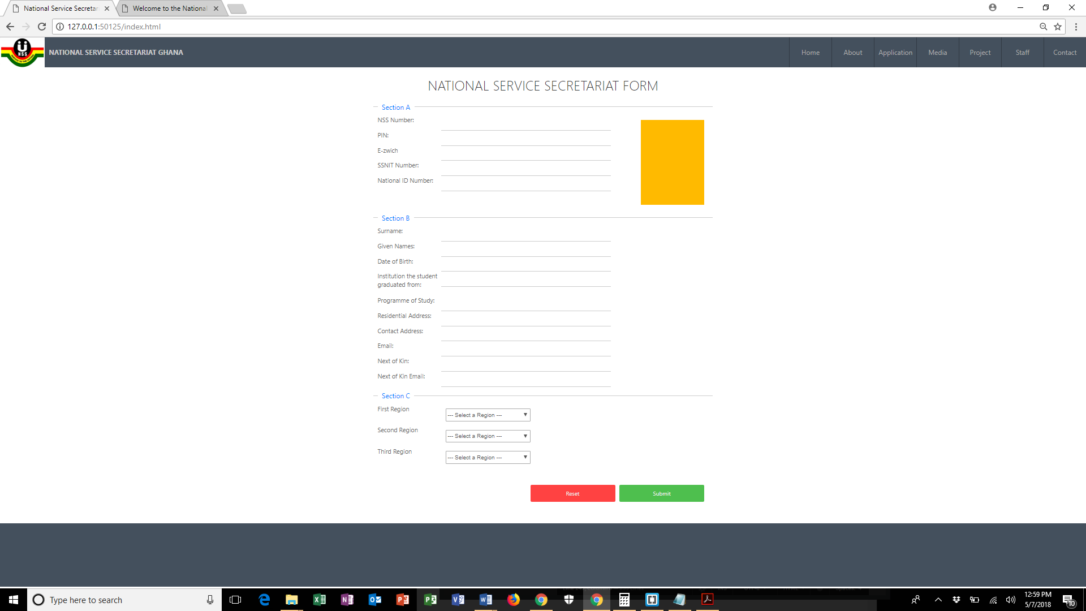

Figure 1 example of what the form should exemplify.

**Paste the CodePen URL here: _________________________________________________**

**Total Points: 4200**

**ALL THE BEST**

**H. B. Essel**